<https://fastapi.tiangolo.com/tutorial/first-steps/>

[Python FAST API Tutorial](https://www.youtube.com/watch?v=-ykeT6kk4bk)

To create a virtual environment.

python -m venv .venv  
source .venv/bin/activate  
pip install uvicorn  
uvicorn main:app --reload

Go to .venv/Scripts and enter activate to activate the virtual environment.

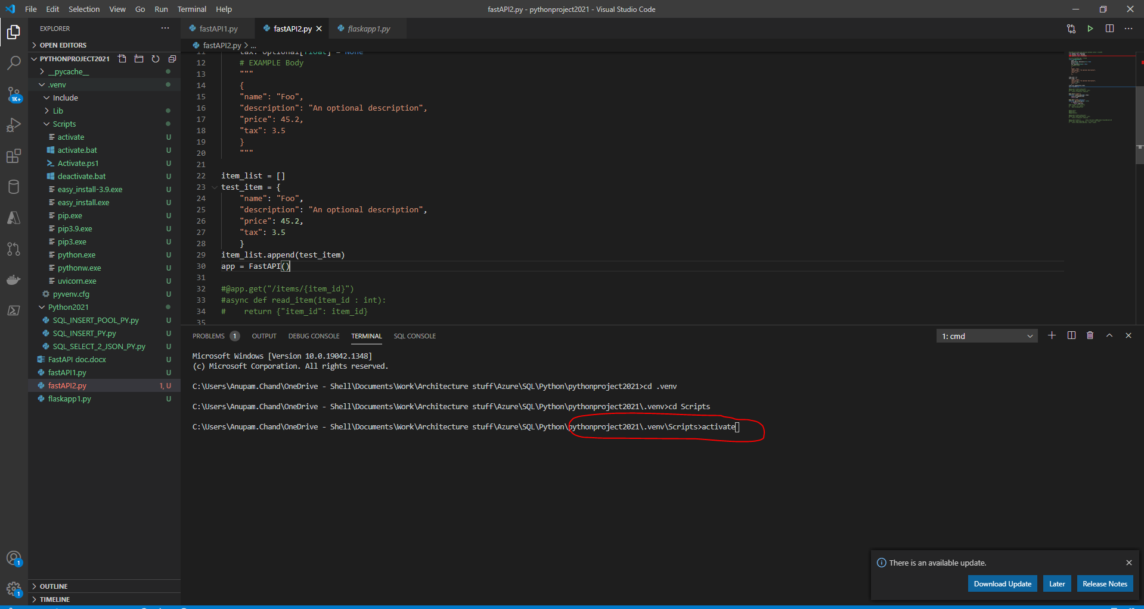

To install any python module into the virtual env

pip install --trusted-host pypi.org --trusted-host files.pythonhosted.org pandas -vvv

To execute the fast API, go to the folder where the fastapi script is present and enter

uvicorn xxxx:app –reload

where xxxx is the name of the python script.

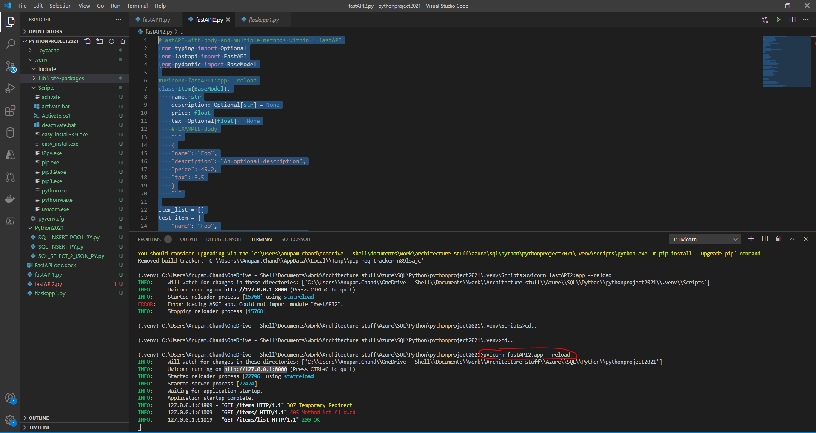

An example script is

#fastAPI with body and multiple methods within 1 fastAPI

from typing import Optional

from fastapi import FastAPI

from pydantic import BaseModel

#uvicorn fastAPI1:app --reload

class Item(BaseModel):

    name: str

    description: Optional[str] = None

    price: float

    tax: Optional[float] = None

    # EXAMPLE Body

    """

    {

    "name": "Foo",

    "description": "An optional description",

    "price": 45.2,

    "tax": 3.5

    }

    """

item_list = []

test_item = {

    "name": "Foo",

    "description": "An optional description",

    "price": 45.2,

    "tax": 3.5

    }

item_list.append(test_item)

app = FastAPI()

#@app.get("/items/{item_id}")

#async def read_item(item_id : int):

#    return {"item_id": item_id}

@app.post("/items/")

async def create_item(item: Item):

    item_list.append(item)

    return item

@app.get("/items/{option}")

async def get_items(option : str):

    if option == 'list':

        return item_list

#app.include_router(router)

#if __name__ == "__main__":

#    app.run(debug=True)

#@app.post()

#@app.put()

#@app.delete()

#@app.get("/items/{item_id}")

#async def read_item(item_id : int):

#    return {"item_id": item_id}

#@app.get("/items/")        http://127.0.0.1:8000/items/?skip=0&limit=10

#async def read_item(skip: int = 0, limit: int = 10):

#    return fake_items_db[skip : skip + limit]

To deploy the fast api to an app service,

<https://techcommunity.microsoft.com/t5/apps-on-azure/deploying-a-python-fastapi-on-azure-app-service/m-p/1757016>

[How to Deploy FastAPI on Azure App Service in just 30 minutes](https://www.youtube.com/watch?v=oLdEI3zUcFg)